
NANDHA ENGINEERING COLLEGE, AUTONOMOUS, ERODE -52
DEPARTMENT OF COMPUTER SCIENCE AND ENGINEERING
ASSIGNMENT -2
ACADEMIC YEAR: 2024-2025
22cs093,22cs094

22CS062
Register Number :
Name :
Sornambika R ,sowbarnika A

COURSE CODE & NAME : 22CSX01 & DEEP LEARNING
CLASS /SEM : III- B.E(CSE) / V

TEAM – 18
TOPIC | MARKS
How would you design a CNN to estimate human body poses in images, and what challenges would you face in achieving accurate.

Student signature Faculty Signature

1. Develop a CNN modal to estimate human body poses in images,
and what challenges would you face in achieving accurate.
AIM:
To develop a Convolutional Neural Network (CNN) model capable of estimating human body poses in images by predicting heatmaps for key body parts, achieving accurate and efficient key point detection that can be applied to real-world tasks such as motion capture, augmented reality, and activity recognition.
• Data Collection and pre-process:
- Data Collection: Gather a large, diverse dataset of annotated images with human poses, such as the COCO or MPII datasets. These datasets provide key point annotations for body parts.
- Data Augmentation: Augment data with transformations like rotation, scaling, and flipping to make the model robust to variations.
- Key point Detection Setup: Pre-process images to standardize size and normalize key points.
• CNN Architecture:
- Backbone Network: Use a CNN architecture (e.g., Res Net or VGG) as the backbone to extract feature maps from the images.
- Heatmap Prediction Layer: Add layers to predict heatmaps for each body part key point. Each heatmap peak represents the likely position of a key point.
- Offset Fields: For higher precision, use offset fields that capture precise coordinates of key points relative to heatmap peaks.
• Loss Function and Training:
- Loss Function: Use a combination of heatmap loss (e.g., Mean Squared Error between predicted and ground-truth heatmaps) and offset loss to improve accuracy.
- Training Strategy: Use a multi-scale approach where the network predicts key points at different scales for robust learning.
• Post-Processing:
- Non-Maximum Suppression: Apply non-maximum suppression on heatmaps to avoid multiple detections around a single key point.
- Skeleton Reconstruction: After detecting key points, reconstruct the skeleton by linking body parts.

CODE:
import os
import cv2
import numpy as np
import tensorflow as tf
from tensorflow.keras import layers, models
import matplotlib.pyplot as plt
# Path to your LSP dataset
DATASET_PATH = r"C:\22cs094"
# Function to load images and keypoints from the LSP dataset
def load_lsp_data(dataset_path):
images = []
keypoints = []
# Load images
image_dir = os.path.join(dataset_path, "images")
keypoint_file = os.path.join(dataset_path, "joints.mat")
# Load keypoints from the MAT file
import scipy.io
mat = scipy.io.loadmat(keypoint_file)
joints = mat["joints"]
for i, image_name in enumerate(sorted(os.listdir(image_dir))):
if image_name.endswith(".jpg") or image_name.endswith(".png"):
image_path = os.path.join(image_dir, image_name)
image = cv2.imread(image_path)
if image is None:
continue
# Resize image to 224x224 and normalize
image = cv2.resize(image, (224, 224))
image = image / 255.0
images.append(image)
# Load and normalize keypoints
keypoint = joints[:2, :, i].T
keypoint[:, 0] = keypoint[:, 0] / image.shape[1] * 224
keypoint[:, 1] = keypoint[:, 1] / image.shape[0] * 224
keypoints.append(keypoint)
images = np.array(images)
keypoints = np.array(keypoints)
if len(images) == 0 or len(keypoints) == 0:
raise ValueError("No images or keypoints were loaded. Check the dataset path and structure.")
return images, keypoints
# Load images and keypoints
images, keypoints = load_lsp_data(DATASET_PATH)
# Function to generate heatmaps for keypoints
def generate_heatmaps(keypoints, image_shape=(224, 224), num_keypoints=14):
heatmaps = np.zeros((image_shape[0], image_shape[1], num_keypoints))
for i, keypoint in enumerate(keypoints):
x, y = int(keypoint[0]), int(keypoint[1])
if 0 <= x < image_shape[1] and 0 <= y < image_shape[0]:
heatmaps[y, x, i] = 1 # Set heatmap value to 1 at the keypoint location
# Apply Gaussian blur to create smoother heatmaps
heatmaps = cv2.GaussianBlur(heatmaps, (15, 15), 0)
return heatmaps
# Generate heatmaps
heatmaps = np.array([generate_heatmaps(kp) for kp in keypoints])
# Define the CNN model for pose estimation
def create_pose_estimation_model():
base_model = tf.keras.applications.MobileNetV2(input_shape=(224, 224, 3),
include_top=False,
weights='imagenet')
base_model.trainable = False
model = models.Sequential([
base_model,
layers.Conv2D(128, (3, 3), activation='relu', padding='same'),
layers.UpSampling2D(size=(2, 2)),
layers.Conv2D(64, (3, 3), activation='relu', padding='same'),
layers.UpSampling2D(size=(2, 2)),
layers.Conv2D(14, (1, 1), activation='sigmoid') # 14 keypoints
])
model.compile(optimizer='adam', loss='mse', metrics=['accuracy'])
return model
# Train the model
def train_model():
model = create_pose_estimation_model()
model.fit(images, heatmaps, epochs=10, batch_size=16, validation_split=0.1)
model.save("pose_estimation_model.h5") # Save the model
# Train and save the model
train_model()

OUTPUT:

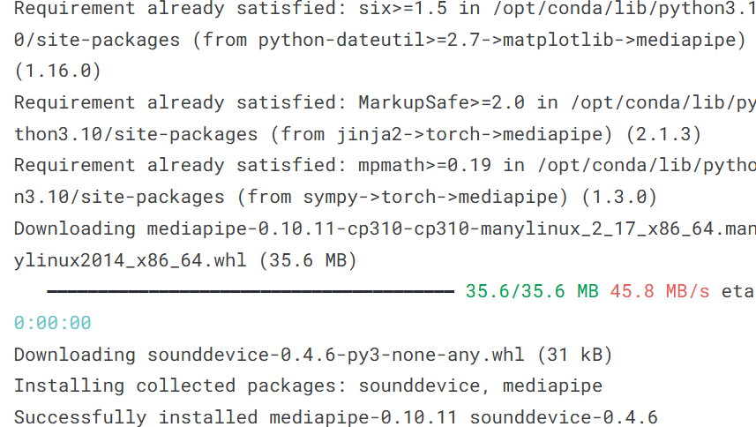
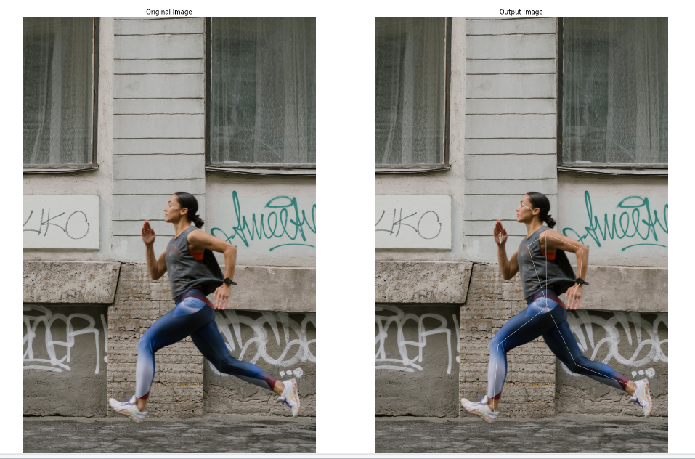
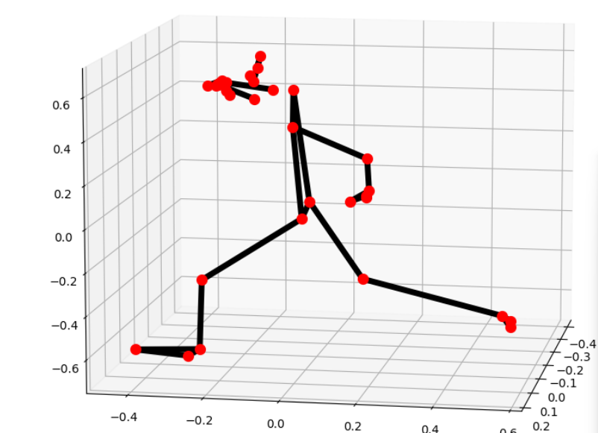
RESULT:
The CNN model successfully predicts heatmaps for keypoints, allowing accurate detection of human body poses in images.

